Chapter 1
Automated Categorization & Mining Tweets for Disaster Management

Rakhi Patra¹,
Mtech BITS Pilani, Kolkata-700156

¹Rakhi.Patra@gmail.com,

Abstract. Recent trend has shown that Twitter is an emerging source to monitor disaster events. Two main objectives here are classification and extraction. In this work machine learning is applied on tweets that are generated during the course of a disaster to categorize & mine tweet messages into different stages of that disaster. Classification & mining result of tweets facilitate government agencies, NGOs, adhoc volunteer groups to use twitter for real time disaster response. An initial effort has spent for manually labelling 1,000 tweet messages into predefined categories according to disaster phases to build a classification model. Thereafter, the trained model is used to automatically categorize the new subsequent tweets in a supervised way of machine learning. The five classes or categories are considered in this work are as preparedness, response, impact, recovery and other. Once the classification is done, next objective is to mine information from the categorized tweet messages like impacted locations, hardest hit areas, volunteer relief organization who are working on, whether that message is a complain, if any disease has spread etc. Thus the result generated after classification and mining helps emergency manager so that they can take action quickly and efficiently in the impacted location.

Keywords. Twitter; disaster; text mining; data mining; disaster coordination; disaster relief
  - Introduction
Since past few years, uses of Twitter service has been growing rapidly as a standard medium for news and communication, especially in the age where people are always connected on mobiles unlike newspaper & TV in past. In times of disasters, Twitter plays a major role in spreading the message fast by posting early alerts and warnings, live updates of emergency situations on-the-ground like magnitude of the disaster, loss & impact, damage severity in time of crisis. People tend to use social media for several reasons to check on family and friends, seek support, gather news on daily updates on weather, safe locations and food & water supplies etc. Thus Twitter can help to track natural disasters in real time and notify first responders to areas that need urgent aid. People can also use Twitter to send donations.
In several countries in Asia, Twitter and Twitter Lite are used by media, nongovernmental organizations (NGOs), public, government agencies and ad-hoc volunteer groups to share, exchange and collaborate critical information and organize relief efforts in times of crisis. Twitter improve relief and rescue operation by mining actionable data for emergency response and relief operation. However, manual examination of millions of unstructured tweet posts is a big challenge in time of crisis.
Purpose of this paper is to apply supervised machine learning technique to understand & analyze the tweets, posted in the time span of a disaster & classify them according to disaster stages. Classified tweets help emergency managers to understand the transition between stages that save their time to organize information, and set priorities and activities during the course of a disaster. Tweet mining is the next step to identify the hardest hit areas , people in the most need, to understand challenges, damages & impacts so that emergency manager, rescue workers can streamline activities accordingly.
This paper introduces a framework that uses IBM NLP & NLU tools which are applied on tweet posts to classify and mine twitter data for disaster analysis. Using this framework, relevant tweets for each category are extracted from the raw tweet text. The subsequent sections of this paper is a general review of the research on using social media in a disaster to provide the broader context for our empirical study, followed by the third section describing the methodology for preparing and mining tweets for disaster analysis. Section four demonstrates how to apply the classification results for the disaster analysis. The paper is concluded with a discussion of the issues, challenges and future research directions of using social media data for disaster analysis and study.

Tweet posts that indicate a scenario of danger, worrying or generic alarm, depicts damage & impacts could prove crucial. Whereas posts that report ironic comments, general comments, expressing gratitude don't seem to be significantly relevant in the context of prioritizing action items during disasters.
1.2 Related works
During natural disaster Twitter can be used as an important tool to track & provide information and instructions w. Social Media has redefined and revolutionized communication during natural disasters. In recent years, many studies have applied social media data to perform disaster management. Social media post are used for (1) situational awareness (2) event detection and sentiment tracking; (3) disaster response and relief coordination; and (4) damage assessment.

In “TEXT MINING ON REAL TIME TWITTER DATA FOR DISASTER RESPONSE” ^{[1]}, twitter post are collected and processed to facilitate disaster managers for better response operations during emergencies. In this study authors, Myneni Madhu Bala, K. Navya, & P. Shruthilaya have used machine learning and text mining algorithms to analyze the sentiments of twitter post generated during a disaster. With this process less significant tweets such as ironical comments are discarded. Whereas subjective tweets with positive sentiments and negative sentiment tweets such as criticize the response or blame the government are considered as important to be processed. In my work, crucial tweets are categorized into four groups (preparedness, response, impact & recover) according to disaster phase and less important tweets are included into ‘other’ category.

Information about early alerts, warnings, impacts, damage and donation efforts are more likely to be used to improve situational awareness during a time-critical event. As a result, messages are typically categorized into these major categories. For instance authors Meera.R.Nair, G.R.Ramya, P.Bagavathi Sivakumar categorized tweets into five classes namely express Gratitude, Relief, Complaint, Need for help and other in ‘Usage and analysis of Twitter during 2015 Chennai flood towards disaster management’. However tweets related to preparedness are not fit to these category.

Qunying Huang and Yu Xiao, define a list of message categories that are involved in each disaster phase. They also explore spatiotemporal pattern of people’s behaviors and reactions by mapping the geographic locations of tweets of a specific category.

Nikos Athanasis, Marinos Themistocleous ,Kostas Kalabokidis have discussed an approach which is based on the enrichment of geospatial modeling results with real-time disaster-related information from social media during an emergency incident.

The intent of this work here is to highlight the role to twitter in real time disaster management. Tweets are categorized according to disaster stages.Compared to similar studies, the added value is by mining tweets to extract useful information such as impacted location, company or organization, if disease spreads in affected area etc .

Methodology
In this work the proposed model consists of two main parts: classification and extraction. In the core of the proposed architecture lies the Apache Kafka component, an open source stream processing platform (Fig. 2).2

Data

In this work, cyclone Fani, which hit the state Odisha in India on 1st May 2019, is selected to create the training model. Tweets with hash tag ‘cyclone fani’ are examined. Cyclone Fani was formed since 26 April 2019 and dissipated 5 May 2019. In order to understand the type of information that has been spread in Twitter before, during and after the disaster, tweets were which posted in the time span of 26th April to 26th May 2019, are retrieved with the help of the keyword #cyclonefani. Tweet messages are retrieved from the Twitter Source by utilizing the Twitter API with predefined has tag for a specified date range. Hash tags and date range are defined though a web based UI. Tweets are then dumped into a text file.

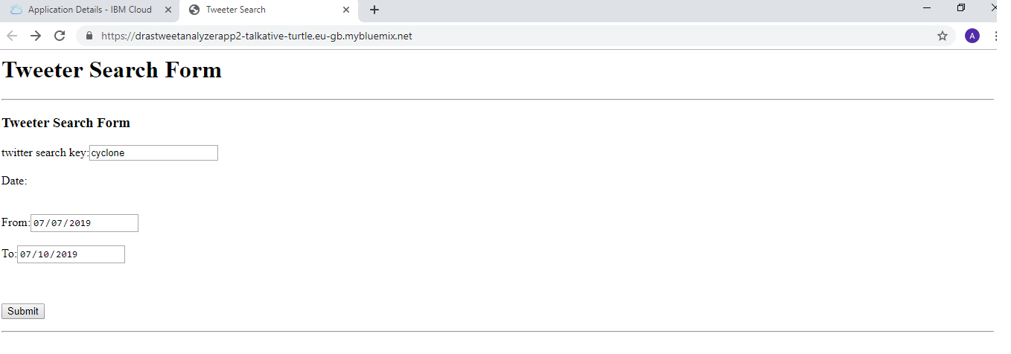

Tweet Categories
A total of 1,000 tweets were collected for this work. To determine the categories of tweets obtained, each messages is manually examined by extracting keywords used in text, characteristics of each message. A tweet is classified to a specific category if it contains associated keywords according to the context of disaster phase. While creating the training model, we also reference official government procedures for different disaster stages [2,3]. Government disaster management process have defined disasters into four stages a) mitigation (prevention and risk reduction), b) preparedness, c) response (immediate rescue) and d) recovery (build-back better). However, mitigation is not considered in this work. Because tweets of this category are less in count as it concerns the long-term measures to prevent future disasters or minimize their effects. This paper primarily focuses on the other three phases. We additionally identified tweets on impact, which is crucial for disaster response. There are many tweet posts which are not crucial to indicate the situational awareness. Therefore, a category called “other” is defined to describe such type of messages.

The five classes or categories considered in this work are as follows:

- Preparedness
This category contains tweets regarding emergency plans; such as evacuation, shelter, stock up.

- Response - This category includes messages that indicates immediate rescue & relief operations, any kind of announcement from airport authority for free shipping of relief aids such as supply of foods, medicines, doctors. If any kind of disease spreads like fever, diarrhea.

- Impact – This category includes messages aftermath, damage measure.

- Recovery - Rebuild
- Other

Train the Classifier Model

During the initial annotation process, we notice that most of the tweets are annotated as the others category, and some categories only contain a very small number of tweets. To ensure that we have enough tweets to build a classification model for the predefined categories, more tweets from each category should be included into the sampling sets which will then be used for the subsequent model training and validation processes. Once the category of each tweet is determined, the initial text file is saved as a csv format as {tweet-text, category}.This csv is then feed to train the classifier model. To build the tweet classifier model, IBM cloud’s natural language classifier (NLC) is used in this work. Once training model has been created successfully it is used predict the category of the new tweets.

Tweet mining

After classification, tweets are further mined to retrieve useful information for disaster analysis. Here tweets are processed by IBM cloud’s natural language understanding (NLU) in order to extract text analytics features like sentiment, location, organization/company, topic etc.

- Sentiment – Negative sentiments are considered as complaints.

Diarrhoea cases on rise in # CycloneFani ravaged # Puri District, which is still battling to overcome the crisis.

- Location – Any location entity used in tweet post.

Cyclonic storm # Fani now 670 km east to Potuvil. Cloudy skies over most parts of # SriLanka. Rains or thundershowers in Western, Southern, Sabaragamuwa, North-Western and Central provinces. Heavy Rains 100mm at some places - MET # LKA # WeatherSL # CycloneFani pic.twitter.com/pPVZZFxiup

- Organization/Company – If the tweet post contains name of the volunteer, NGO organization.

Air India: National carrier Air India steps forward to help the residents of Odisha affected by # CycloneFani . If any (NGO/ Civil society/ SHG etc) wants to send relief materials to cyclone affected area of Odisha, Air India would ship it free of cost.

ICICIBank today launched ‘Mobile ATM vans’ in association with @ bmcbbsr. The service was inaugurated by Ms. Ananya Das, IAS & Add. Commissioner, @ bmcbbsr and is specially organised to serve the people of the city till ATM normalcy is attained.

- Topic-

Diarrhoea cases on rise in # CycloneFani ravaged # Puri District, which is still battling to overcome the crisis.

CycloneFani in the Bay of Bengal is expected to strengthen as it moves northwards in the coming days. Uncertainty about landfall location at this stage. Nick pic.twitter.com/9yUeDzzXTk

Tweet message
Dump into .text file
Manually annotate categories
Train and build classifier model
Determine category of new tweets
Extract text analytics features like entities, location, company etc.
Classification
Extraction

Fig. 1 – Conceptual design of the proposed methodology

Fig. 2 – Architectural components of the proposed methodology

RESULTS AND Discussion

The classifier has been validated on tweets collected with hashtag #CycloneVayu ,#CycloneTitli & NepalEarthquake. Classification results is generated as expected. The result can be visualized in JSON format through a web-based visualization platform.

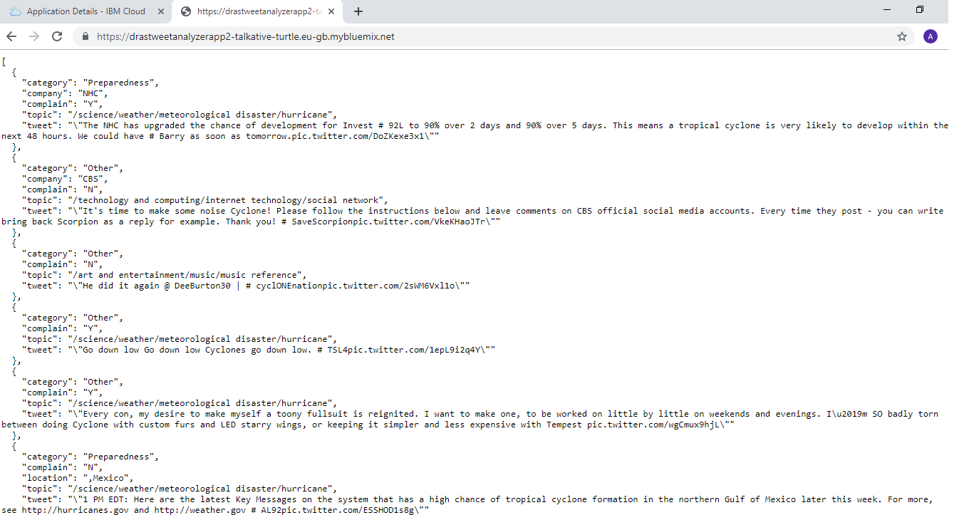

There is also an option available to download the result in excel format. Excel has five sheets according to disaster stages. Each sheet contains tweets of that category. To sum up the result, excel has fields such as if the message is complaint, impacted location, company or organization working on, if any disease spread.

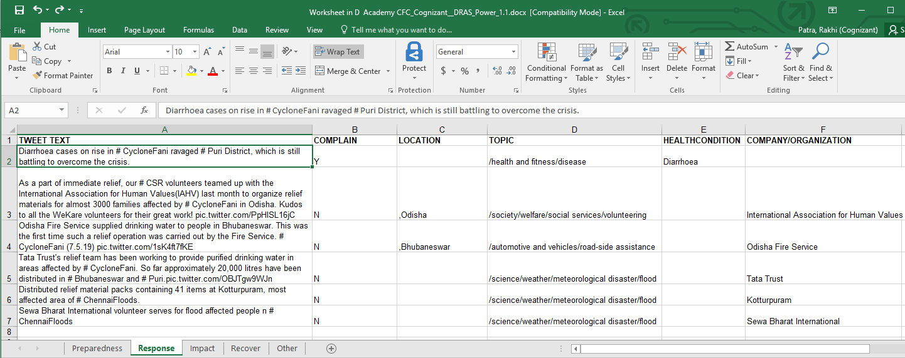

Conclusion
This paper presents classifier & mining model that could be used to automatically classify tweets of natural hazards, especially cyclone related ones. Thus the model could help, support real-time disaster management and analysis by monitoring subsequent events while tweets are streaming, and mining useful information.

Additional information from tweets like originator of tweets, user type (Individuals, Celebrities, Journalists, News organizations, Government or NGOs), date & time of tweets could. Our goal is to run the tweet classifier program as a continuous process during a disaster outbreak which will capture whenever a new tweet is posted. Timing and other inputs should be configurable from UI. Future plan extend the functionalities by adding damage severity assessment by analyzing the images posted with tweet messages.
References
- Myneni Madhu Bala, K. Navya. P. Shruthilaya, TEXT MINING ON REAL TIME TWITTER DATA FOR DISASTER RESPONSE. International Journal of Civil Engineering and Technology (IJCIET), 27(11).
- https://ndma.gov.in/images/policyplan/dmplan/National%20Disaster%20Management%20Plan%20May%202016.pdf
- https://www.undp.org/content/dam/india/docs/disaster_management_in_india.pdf
- Meera.R.Nair1, G.R.Ramya1,P.Bagavathi Sivakumar. Usage and analysis of Twitter during 2015 Chennai flood towards disaster management. 7th International Conference on Advances in Computing & Communications, ICACC-2017,22-24 August 2017, Cochin, India
- Qunying Huang 1,* and Yu Xiao, Geographic Situational Awareness: Mining Tweets for Disaster Preparedness, Emergency Response, Impact, and Recovery. ISPRS International Journal of Geo Information ,ISSN 2220,9964
- Nikos Athanasis1,*, Marinos Themistocleous1, Kostas Kalabokidis2
Apostolos Papakonstantinou2, Nikos Soulakellis2, Palaiologos Palaiologou3 THE EMERGENCE OF SOCIAL MEDIA FOR NATURAL DISASTERS MANAGEMENT: A BIG DATA PERSPECTIVE. The International Archives of the Photogrammetry, Remote Sensing and Spatial Information Sciences, Volume XLII-3/W4, 2018
GeoInformation For Disaster Management (Gi4DM), 18–21 March 2018, Istanbul, Turkey

